Waterloo Community School District Secondary Breakfast

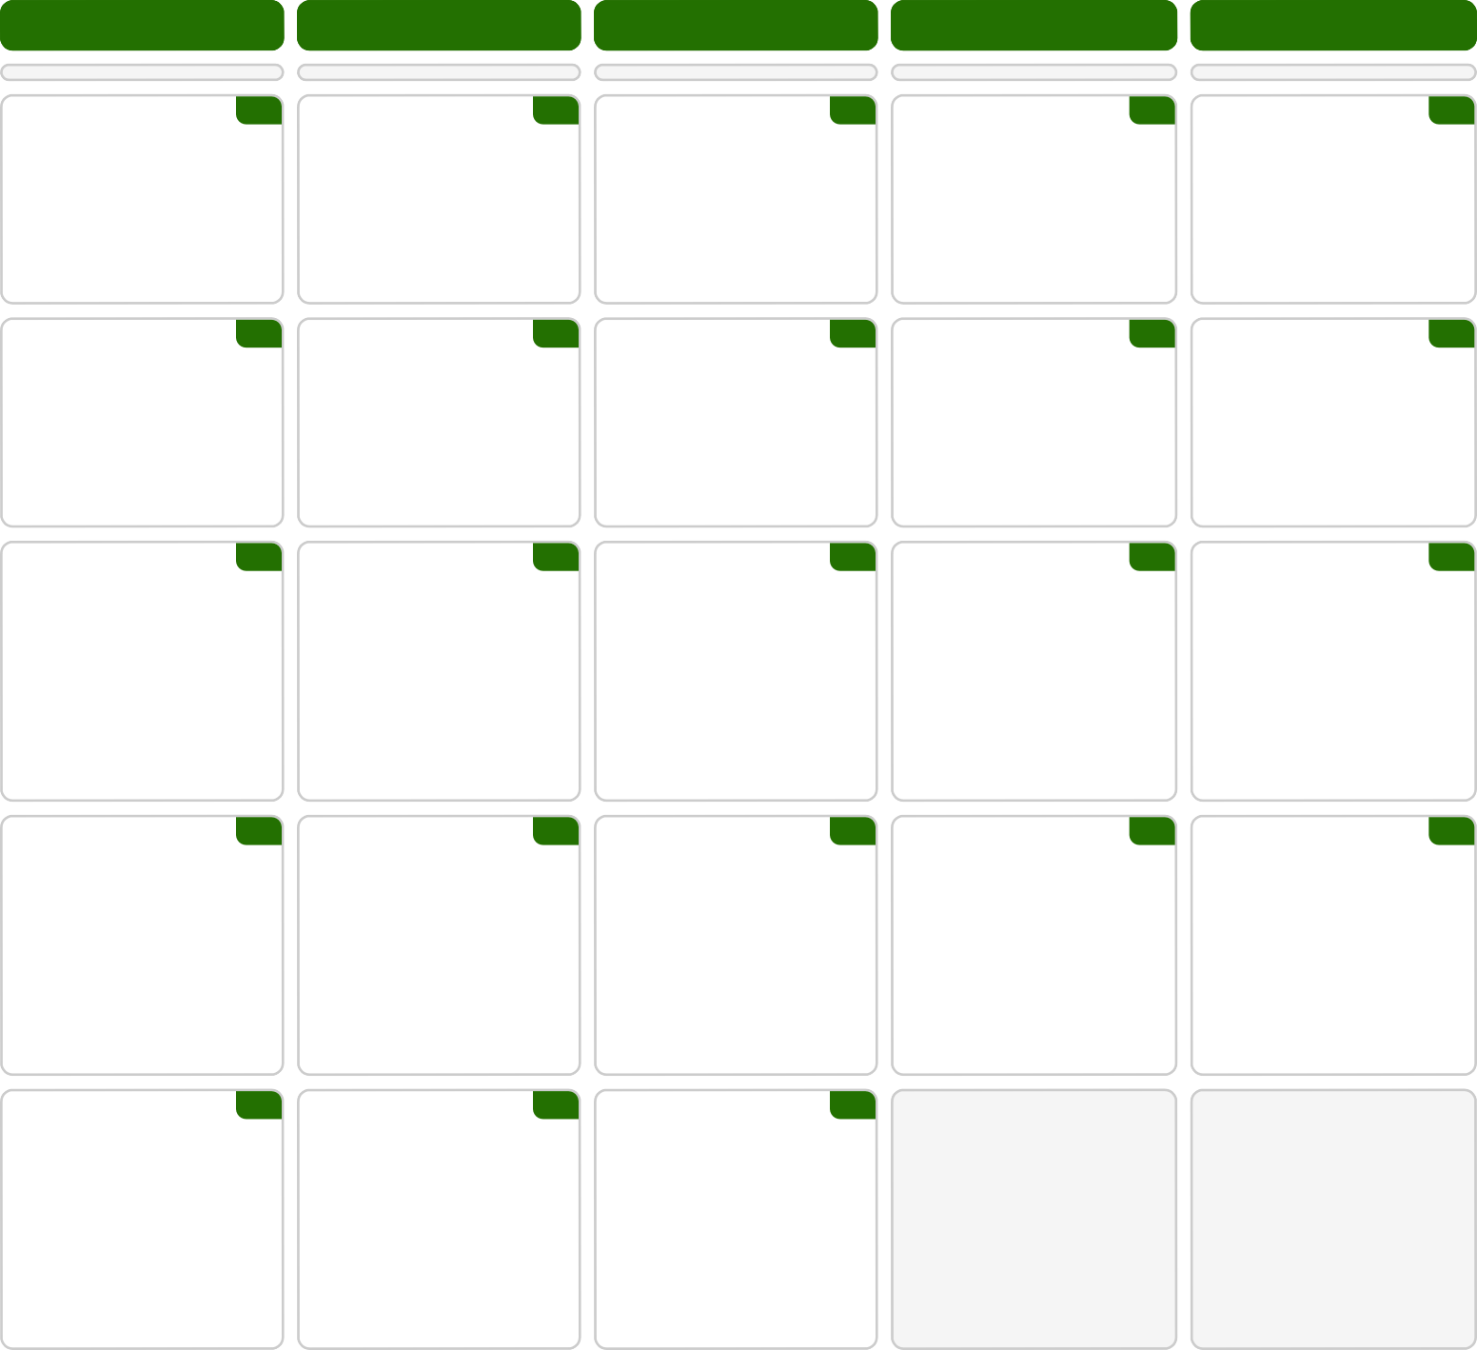

Monday Tuesday Wednesday Thursday Friday

3  Breakfast | 4  Breakfast | 5  Breakfast | Breakfast | 6 | Breakfast | 7
Trix 18 | Lucky Charms 21 | Cinn Crunch Cereal 21 | Apple Jacks 24 |  | Strawberry Shredded
Chocolate Oatmeal Bar 24 | Choc Chip Crisp 25 | Poptart, Cinnamon 37 | S-berry Grain Bar 27 |  | Wheat
Orange Juice 13 | Fruit Punch 14 | Grape Juice 18 | Apple Juice 14 |  | Cereal Bar 30
Raspberry lemonade | Mandarin Orange Cup | Applesauce 13 | Pear Cup 18 |  | Juice 15
Craisins 28 | 17

10  Breakfast | 11  Breakfast | 12  Golden Grahams 24 | Breakfast | 13 | Breakfast | 14
Froot Loops 16 | Cheerios 14 | Poptart, Blueberry 37 | Fruity Cheerios 25 |  | Frosted Flakes 24
Honey bun goldfish 19 | Apple Grain Bar 27 | Grape Juice 18 | Cinnamon Crisp 25 |  | Donut 23
Orange Juice 13 | Fruit Punch 14 | Applesauce 13 | Apple Juice 14 |  | Juice 15
Raspberry lemonade | Mandarin Orange Cup |  | Pear Cup 18 |  | Fruit barrel
Craisins 28 | 17

Breakfast | 17 | 18  Breakfast | 19  Breakfast | 20  Breakfast | 21  Breakfast
Coco Puffs 21 |  | Lucky Charms 21 | Trix 18 | Frosted Flakes 24 | Cheerios 14
Butterscotch Bar 24 |  | Poptart, Fudge 37 | Breakfast Cookie 44 | Apple Delight Bar 27 | Berry/Lemon Cracker 21
Orange Juice 13 |  | Fruit Punch 14 | Grape Juice 18 | Apple Juice 14 | Juice 15
Applesauce 13 |  | Mandarin Orange Cup | Raspberry lemonade | Pear Cup 18
 |  | 17 | Craisins 28

24
Breakfast Apple Jacks 24
Campfire S’more 24
Orange Juice 13
25
Breakfast Froot Loops 16
Granola Bar 19
Fruit Punch 14
26

Manager's Choice Breakfast

Manager's Choice Breakfast
27 28

Manager's Choice Breakfast

Applesauce 13
Mandarin Orange Cup 17

31 1 2

Manager's Choice Breakfast
Manager's Choice Breakfast

We are always looking for Food Service Substitutes. Contact Human Resources today! Milk is offered with all meals
Menus are subject to change

This Institution is an Equal Opportunity Provider

* Items are a pork product

