Waterloo Community School District Secondary Lunch

Monday Tuesday Wednesday Thursday Friday

3  Breaded Chicken Sand. 45 | Sloppy Joe 43 | 4 | 5  Chicken Drumstick 5 | 6  Hamburger 33 | 7  Taco Burger 36
Chili Crispito/Cheese 38 | Chicken Taco 19 |  | Lasagna 44 | Mandarin Chicken 61 | French Bread Cheese 27
Ham,turkey, cheese sub 52 | Yogurt Box 53 |  | Garlic bread 16 | Brown Rice 21 | *Ck Bacon Ranch Pizza 44
Lettuce Cup 3 | Potato Wedges 17 |  | Chef Salad 14 w/ | *Chicken Club Wrap 48 | Nacho box Box 34
Refried Beans 15 | Cucumbers 3 |  | Corn Muffin 36 | Sweet Pot Crinkles 17 | Broccoli w/ Cheese 5
Mini Carrots 3 | Pears 25 |  | Peas 13 | Cherry Tomato 2 | Green Pepper Strips 3
Strawberry Cup 32 | Apple Juice 14 |  | Romaine Lettuce Salad | Mandarin Oranges 28 | Mixed Fruit 25
Orange Juice 13 | Animal Crackers 21 |  | Cinnamon Apples 29 | Fruit Punch 14 | Juice 15
Bear Grahams 21 |  |  | Grape Juice 18 | Berry/Lemon Cracker 21 | Honey bun goldfish 19
 |  |  | Goldfish 16 | Lettuce Cup 3

10
French Toast Sticks 28
*Sausage 0
Chicken Strips 13 Ham,turkey, cheese sub 52 Lettuce Cup 3
Cheesy Potatoes 17
Cole Slaw 12
Strawberry Cup 32
Orange Juice 13
Bear Grahams 21
11
Chicken Cordon Bleu 44 Walking Taco 26
Yogurt Box 53
Refried Beans 15 Romaine Lettuce Salad Peaches 24
Apple Juice 14
Animal Crackers 21
12
Spicy Chicken Sand. 47 Mozzarella Sticks 48
Southwest Chicken 47
Mixed Vegetables 12
Cherry Tomato 2 Sour Cherry Slushie 20
Grape Juice 18
Goldfish 16
13
Cheeseburger 34 Chicken Parm Bake 28 Chicken Ranch Wrap 48 Potato Wedges 17
Lettuce Cup 3
Mandarin Oranges 28
Fruit Punch 14
Berry/Lemon Cracker 21
14
Chicken Nuggets 15
Tea Roll 13 French Bread Cheese 27
Taco Pizza 61 Nacho box Box 34 Steamed Carrots 7
Fresh Broccoli 2
Mixed Fruit 25
Juice 15 Honey bun goldfish 19

17
Hamburger 33
Mozzarella Sticks 48 Sweet Pot Crinkles 17
Ham,turkey, cheese sub 52 Lettuce Cup 3
Romaine Lettuce Salad Strawberry Cup 32
Orange Juice 13
Bear Grahams 21
18
Chicken Philly Sand. 50 Taco 22
Yogurt Box 53
Potato Wedges 17
Cherry Tomato 2
Pears 25
Apple Juice 14
Animal Crackers 21
19
Breaded Chicken Sand. 45 Macaroni & Cheese 25
* Chicken Bacon Salad 7 w/ Muffin 36
Green Beans 6 Romaine Lettuce Salad Flavored Applesauce 29
Grape Juice 18
Goldfish 16
20
Hot Ham & Swiss 32 Sweet & Sour Chicken 34 Brown Rice 21
Buffalo Chicken Wrap 20 Steamed Broccoli 4
Cucumbers 3
Mandarin Oranges 28
Fruit Punch 14
Berry/Lemon Cracker 21
21
Beef Enchilada 49 French Bread Pepperoni 27
Nacho box Box 34 Refried Beans 15
Mini Carrots 3
Mixed Fruit 25
Juice 15 Honey bun goldfish 19

24
BBQ Beef Sandwich 42 Chicken Nuggets 15 Ham,turkey, cheese sub 52 Lettuce Cup 3
Mashed Potatoes 17
Gravy 3
Cherry Tomato 2
Strawberry Cup 32
Orange Juice 13
Bear Grahams 21
25
Mozzarella Sticks 48 Beef & Cheese Nachos 46
Yogurt Box 53
Corn 16
Cole Slaw 12
Peaches 24
Apple Juice 14
Animal Crackers 21
26

Manager's Choice Lunch

Manager's Choice AfterSchool Snack

Manager's Choice Lunch

Manager's Choice AfterSchool Snack
27 28

Manager's Choice Lunch

Manager's Choice AfterSchool Snack

31 1 2

Manager's Choice Lunch

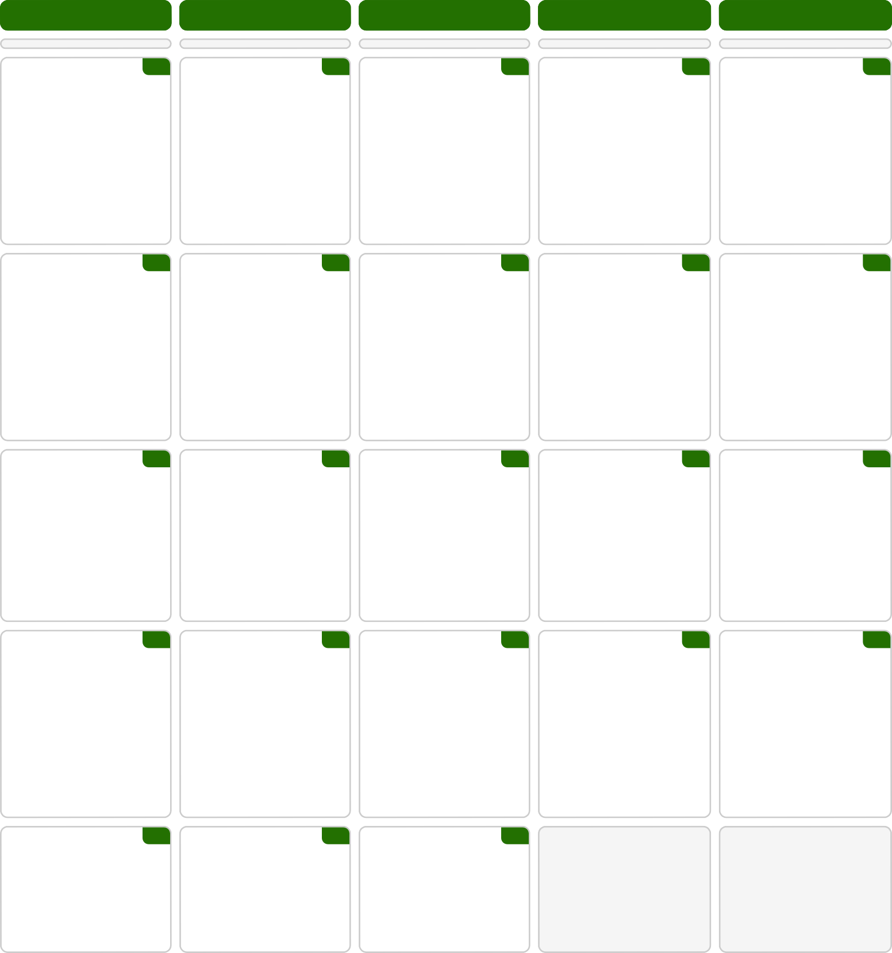

Manager's Choice AfterSchool Snack
Manager's Choice Lunch

Manager's Choice AfterSchool Snack

